FITMATE

**Objective**

Our objective is to create an android application that works for the sake of

people’s health who’s using most of their time on their smartphones and for the

people who wants to hit the gyms for body fitness and stuff.

FitMate adds a totally new dimension to your fitness regime via the FitMate APP. Track your steps, distance and milestones with your smartphone. FitMate gets you real results, anytime and every time and helps achieve your health and fitness goals faster.

# Introduction

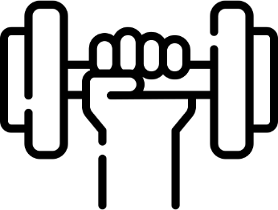

Now-a-days many people have become health conscious and they are concentrating on their body fitness. We see many people going for jogging, doing exercises, hitting gyms, Cycling etc....

Combining the popularity of mobile devices with the on-going search for fitness, we came up with this FitMate App which allow users to set fitness goals, track activity, gather workout ideas.

# Literature survey

There are thousands of fitness-related smartphone applications available for free and purchase, but there is uncertainty if these apps help individuals achieve and maintain personal fitness. Technology usage attrition is also a concern among research studies on health technologies.

**Some of the fitness apps**

**Runtastic -** It is a fitness tracker app for anyone who likes to exercise daily. It uses GPS to track your running, walking, biking, and jogging routes. Runtastic uses this tracked information to create detailed graphs and tables regarding your progress. You can also use the application on a treadmill or other gym equipment.

**Nike training club –**It is also a fitness app which covers over 160 free workouts that focus on strength, endurance, or mobility and offer three levels of difficulty.

**Strava GPS** - This app permits you to track your run, map a cycling route, and analyze your training with all the stats. One of the exciting features of Strava is that it contains a leaderboard where you can challenge yourself.

**Run Tracker** - This app takes advantage of GPS enabled mobile phones to track fitness activities and give comparable results. Runkeeper can calculate running pace, cycling speed, route distance, elevation, and calorie burn with high accuracy. It allows its users to view a detailed history of activities

**Calorie counter** - Calorie Counter is one of the best fitness apps to help you lose weight. And it helps you do so by keeping a track of what you eat all day.

We took these applications as reference for implementing our FitMate app.

## Architecture

1. Login Formats:



FitMate

E-mail login

gmail login

facebook login

Number login

If not user,

create account

If not user,

create account

If not user,

create account

If not user,

create account

already a user,

login

already a user,

login

already a user,

login

already a user,

login

1. Process steps:



After login

Food

steps

videos

select food

items

set goal(No of

steps)

see the inbuilt

vedio

get calories

walk and check

progress

get fat

## Methodology

As for the methodology, we had to use Android Studio to develop this application as Android Studio has large community base which can be helpful to us for solving

the issues that we face, and also has a better interface to do various things to help the development.

Android Studio is also used to automate many things like api’s in to the

application, for example… food API (Nutritionix) which was used to make all the food items in one place for selection for counting of calories and fat from the food intake, and google fit rest API which is used to get us the number of steps that we have walked by making use of the sensors of our smartphone.

We also had to make use of firebase. Firebase is a mobile and web-application development program by Google for the development of software applications.

This provides databases for the storage of any details through online storage mechanism. This is used to store the information that is provided by the user consisting of the goals and food intake.

## Experimentation and evaluation

**Code:**

**ACCOUNT ACTIVITY:**

**package** com.example.maddi.fitness;

**import** android.content.Intent;

**import** android.os.Bundle;

**import** android.support.design.widget.NavigationView; **import** android.support.v4.view.GravityCompat; **import** android.support.v4.widget.DrawerLayout;

**import** android.support.v7.app.ActionBarDrawerToggle; **import** android.support.v7.app.AppCompatActivity; **import** android.support.v7.widget.Toolbar;

**import** android.view.MenuItem; **import** android.view.View; **import** android.widget.TextView;

**public class** AccountActivity **extends** AppCompatActivity **implements**

NavigationView.OnNavigationItemSelectedListener, AccountFragment.OnChangeGoalListener {

**private** NavigationView navigationView;

**private** DrawerLayout drawerLayout;

@Override

**public void** onCreate(Bundle savedInstanceState) { **super**.onCreate(savedInstanceState); setContentView(R.layout.account_activity);

Toolbar toolbar = (Toolbar) findViewById(R.id.toolbar); setSupportActionBar(toolbar); getSupportFragmentManager().beginTransaction()

.replace(R.id.container, **new** AccountFragment())

.commit();

navigationView = (NavigationView) findViewById(R.id.navigation_view); navigationView.setNavigationItemSelectedListener(**this**);

View mHeaderView = navigationView.getHeaderView(0);

TextView nameId = (TextView) mHeaderView.findViewById(R.id.txt1); nameId.setText(LoginActivity.USER_NAME);

TextView emailId = (TextView) mHeaderView.findViewById(R.id.txt2); emailId.setText(LoginActivity.USER_EMAIL);

drawerLayout = (DrawerLayout) findViewById(R.id.drawer); ActionBarDrawerToggle actionBarDrawerToggle =

**new** ActionBarDrawerToggle(**this**, drawerLayout, toolbar, R.string.open_drawer, R.string.close_drawer) {

@Override

**public void** onDrawerClosed(View drawerView) {

**super**.onDrawerClosed(drawerView);

}

@Override

**public void** onDrawerOpened(View drawerView) {

**super**.onDrawerOpened(drawerView);

}

};

drawerLayout.setDrawerListener(actionBarDrawerToggle); actionBarDrawerToggle.syncState();

}

@Override

**public boolean** onNavigationItemSelected(MenuItem item) {

**int** id = item.getItemId();

**switch** (id) {

**case** R.id.item1:

Intent intent = **new** Intent(**this**, MainActivity.**class**); startActivity(intent);

**break**;

**case** R.id.item2:

intent = **new** Intent(**this**, OverviewActivity.**class**); startActivity(intent);

**break**;

**case** R.id.item3:

intent = **new** Intent(**this**, AccountActivity.**class**); startActivity(intent);

**break**;

**case** R.id.item4:

Intent myIntent = **new** Intent(**this**, LoginActivity.**class**); myIntent.setFlags(Intent.FLAG_ACTIVITY_CLEAR_TOP);*// clear back stack* startActivity(myIntent);

finish();

**default**:

**break**;

}

drawerLayout.closeDrawer(GravityCompat.START);

**return true**;

}

@Override

**public void** onChangeGoalClicked() {

Intent myIntent = **new** Intent(**this**, SetGoalActivity.**class**); startActivity(myIntent);

}

}

**USER:**

**package** com.example.maddi.fitness;

**public class** User { **public** String **name**; **public** String **phone**; **public** String **gender**; **public int age**; **public** String **height**; **public float weight**; **public int stepgoal**;

**public int caloriegoal**;

**public** User(String name, String phone, String gender, **int** age, String height,

**float** weight, **int** stepgoal, **int** caloriegoal) {

**this**.**name** = name; **this**.**phone** = phone; **this**.**gender** = gender; **this**.**age** = age; **this**.**height** = height; **this**.**weight** = weight; **this**.**stepgoal** = stepgoal;

**this**.**caloriegoal** = caloriegoal;

}

}

## Overall Result

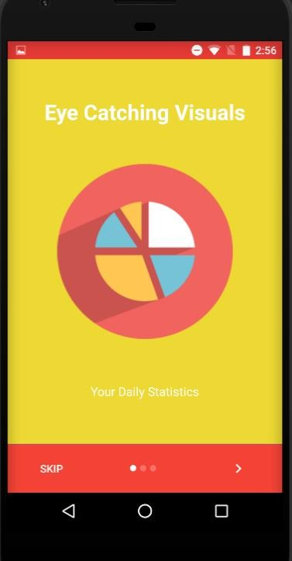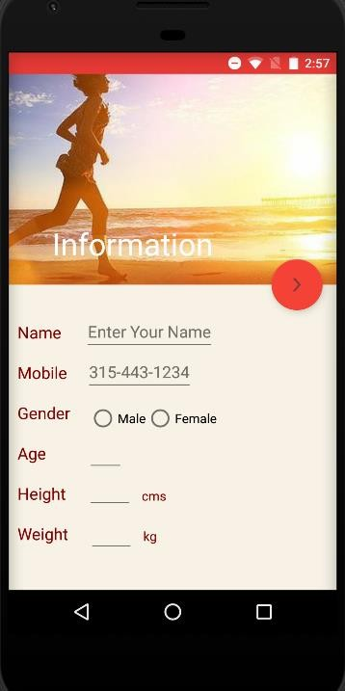

**Conclusion:**

So, by this we conclude that our app has more features than other apps present in the market. This is helpful and user friendly to the people who are familiar with Fitness apps and other apps. As our application combines the counting of steps

and calories counter based on food intake, we can say that, why can’t we use this application rather than going for 2 applications. FitMate is the solution for these problems, which will bring most of the features to one place in one app.